How to add an AMP file to a client Inc portal:
- Download an existing AMP file from any client by going to “Run an Automation Policy”, selecting a Repository item, and then click on the File Name.
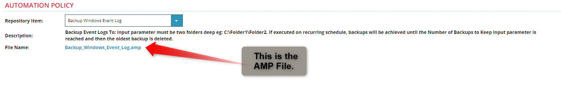
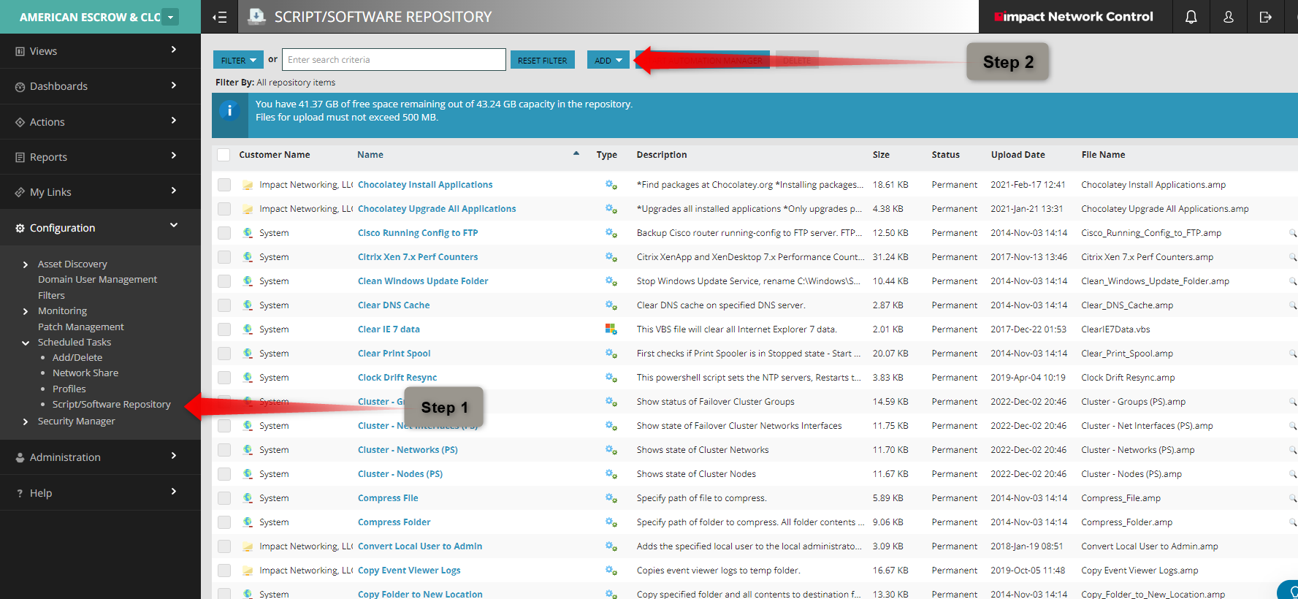
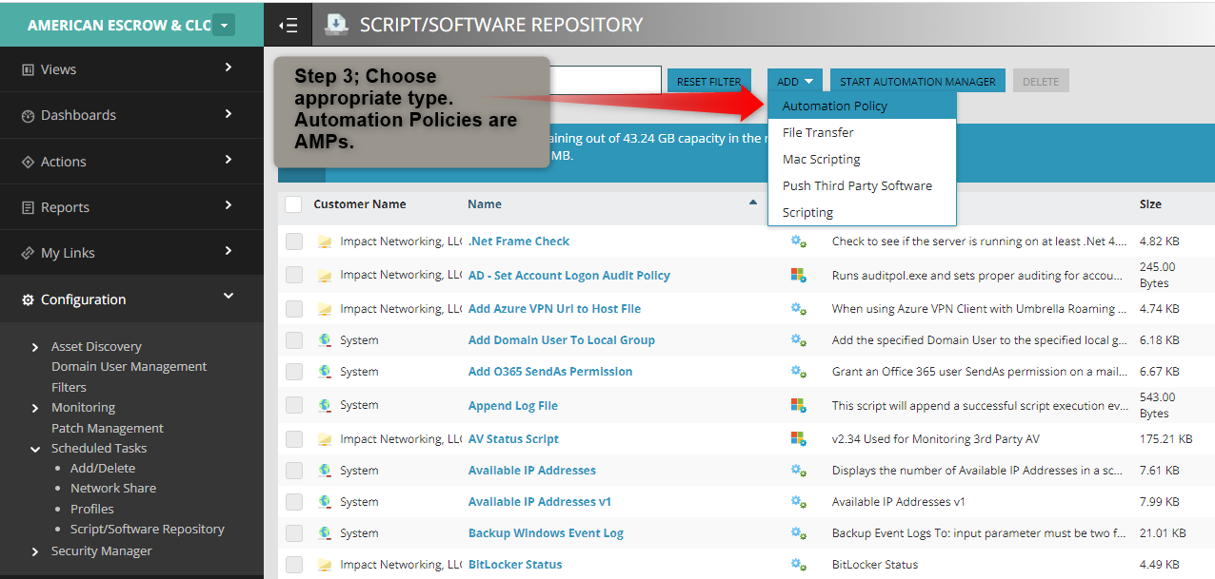

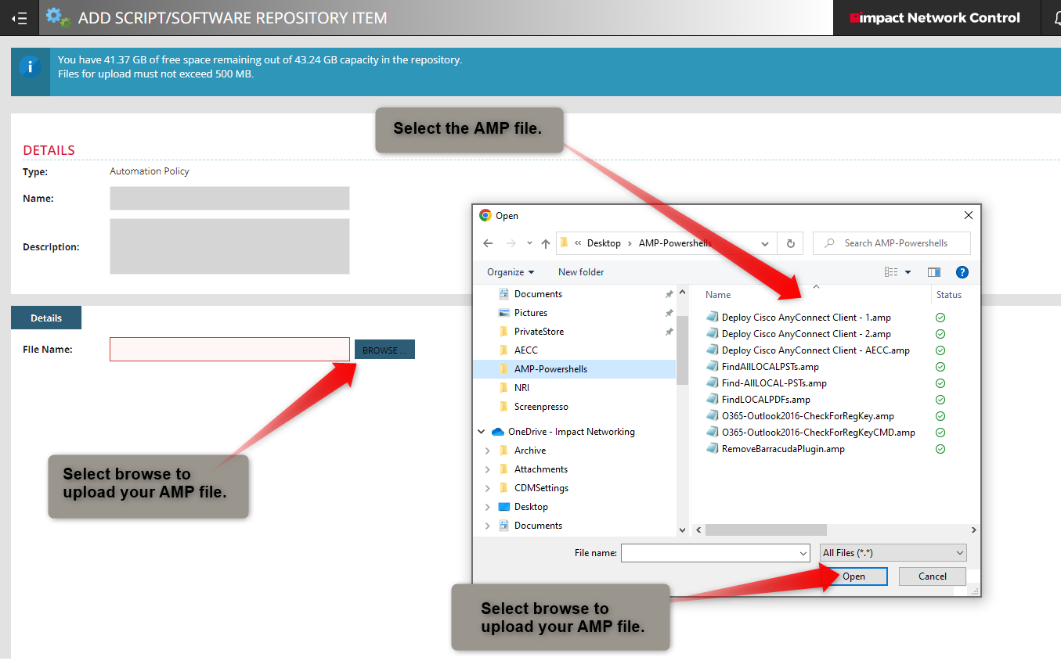

- And that is all…

